@multiLevelInheritance

#include<iostream>

using namespace std;

class Animal {

public:

int age;

int weight;

public:

void speak() {

cout << "Speaking " << endl;

}

};

class Dog: public Animal {

};

class GermanShepherd: public Dog {

};

int main() {

GermanShepherd g;

g.speak();

return 0;

}

Multilevel inheritance is a type of inheritance in C++ where a class is derived from another derived class, forming a chain of inheritance. In other words, a class C inherits from a class B, which itself inherits from a class A. This creates a multi-level hierarchy.

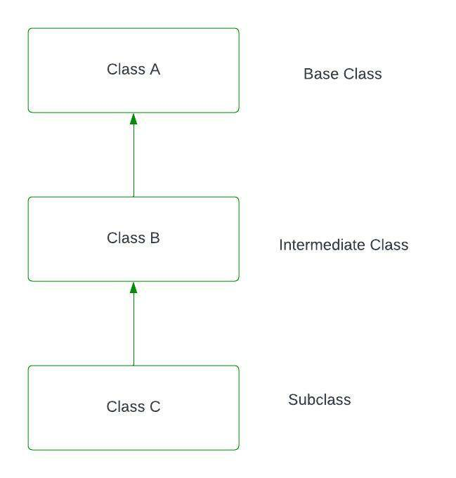

#include <iostream>

using namespace std;

// Base class (Grandparent)

class Grandparent {

public:

void showGrandparent() {

cout << "Grandparent class" << endl;

}

};

// Intermediate class (Parent) inheriting from Grandparent

class Parent : public Grandparent {

public:

void showParent() {

cout << "Parent class" << endl;

}

};

// Derived class (Child) inheriting from Parent

class Child : public Parent {

public:

void showChild() {

cout << "Child class" << endl;

}

};

int main() {

Child obj;

// Accessing methods from Grandparent, Parent, and Child classes

obj.showGrandparent(); // Method from Grandparent class

obj.showParent(); // Method from Parent class

obj.showChild(); // Method from Child class

return 0;

}

**Explanation:**

1. **Grandparent Class:**
   * **This is the base class at the top of the hierarchy. It contains a method showGrandparent().**
2. **Parent Class:**
   * **Inherits from the Grandparent class using public inheritance. It adds its own method showParent().**
3. **Child Class:**
   * **Inherits from the Parent class (which in turn inherits from Grandparent). It adds its own method showChild().**

Output:

Grandparent class

Parent class

Child class